Omega Blade: Accelerometer

Team 2: Swordsmiths

Derrian Glynn

# Introduction

In the Omega Blade project, each of the individual blades, as well as when they are combined into the Omega Blade, have components that are activated when the blade has been swung at a certain force. In order to detect when the sword is being swung, an accelerometer must be installed into the blade itself to send a signal to activate the components. This report will detail what elements will considered for choosing the proper accelerometer for the project.

# Wanted Accelerometer Features

## Range

Each sword needs to activate certain elements when the blade is in motion, however each blade has to be swung at a certain force to activate. For example, the Alpha blade should be activated with a light swing, while the Beta blade must activate with a heavy swing. In order to accomplish this goal the blades must be fitted with accelerometers that can measure that acceleration.

In figure above, each spike represents the g force of a measured swing based on an accelerometer. For the 3 swings measurements needed for the blades, the accelerometer must be able to measure g-force from 0 – 12g.

## Voltage

With a 5 volt battery installed in each blade, the accelerometer should be able to run on a voltage supply of 5 volts or less to save on resources.

## Output Interface

Accelerometers can have in 2 different output interfaces, digital and analog. The digital interface outputs an 8 bit signal pulse of its current acceleration against a clock timer, while the analog outputs a voltage from axises available on the accelerometer. While both have their benefits, an analog accelerometer is needed for this project as the microcontroller does not have any free inputs to receive digital input from an accelerometer.

# Accelerometer Models

With the factors taken into consideration, several models were selected to be considered for this project.

## MMA7341LC 3-Axis Accelerometer ±3/9g with Voltage Regulator

This model can detect an acceleration force of either 3g or 9g depending on the signal sent into it. The system requires a minimum of 2.2V to operate and has an analog output that goes from 1.551 to 1.749 for the individual axises.

## MMA7361LC 3-Axis Accelerometer ±1.5/6g with Voltage Regulator

This model can detect an acceleration force of either 1.5g or 6g depending on the signal sent into it. The system requires a minimum of 2.2V to operate and has an analog output that goes from 1.485 to 1.815 for the individual axises.

## SparkFun Triple Axis Accelerometer Breakout - ADXL337

This model can detect an acceleration force of 3g. The system requires a minimum of 1.8V to operate and has an analog output that goes from 1.485 to 1.815 for the individual axises.

## DataSheet

The Datasheet below shows the differences between the 3 models.

|  |  |  |  |
| --- | --- | --- | --- |
| ***Accelerometers*** | **MMA7341LC** | **MMA7361LC** | **ADXL337** |
| *Range* | 3g or 9g | 1.5g or 6g | 3g |
| *Voltage Input* | 2.2 - 3.6 | 2.2 - 3.6 | 1.8 |
| *Output* | Analog | Analog | Analog |
| *Package* | Breakout Board | Breakout Board | Breakout Board |
| *Axis* | (X, Y, Z) | (X, Y, Z) | (X, Y, Z) |
| *Current* | 400 μA | 400 μA | 300μA |
| *Cost* | $11.95 | $11.95 | $9.95 |

# Selection

While the ADXL337 has lower Voltage requirements, the MMA7341LC (3g or 9g) is the best option as it has a larger range that is a better fit for the regular and heaver swings of the blades. The ADXL337 or the MMA7361LC could be used in the Alpha blade, the other accelerometer can be set low for the alpha and using the same accelerometer keeps resources needed for configuring the accelerometer low such as placing in the swords.

# Software

As the accelerometer outputs a voltage for the system to activate, some coding has to be done on the microcontroller to process the information coming from the accelerometer.

## Log data

To see if the sword has been swung to meet the force requirements for the blade, the microcontroller must be able to keep track of what is output from the accelerometer as it outputs to the microcontroller on a regular interval.

## Check data

After the data has been logged, it is checked to see if the voltage passed the threshold for the specific blade. If it does pass, the microcontroller sends signals to several other components to activte.

## Send IR

Once the microcontroller has been notified it has been swung, it must send specific messages to the sending IR LEDs to notify other devices that they have been hit by a specific blade.

## Modifying Threshold

Once the 4 blades are combined into forming the Omega Blade, some of the microcontrollers must have their thresholds modified since being in Omega requires less force for the blade to activate. Flowchart

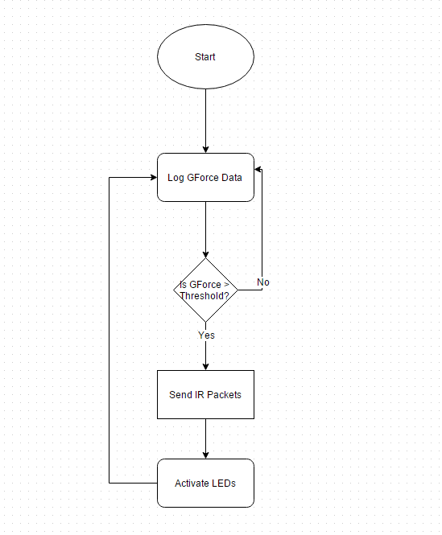

Omega Blade: Connection

Team 2: Swordsmiths

Derrian Glynn

# Introduction

As the four blades are designated to come together to form one blade, each of the blades needs to be notified that it has entered Omega Blade Mode and needs to change behaviors. This report will cover the hardware and programming recommended to have the blades in Omega mode.

# Hardware Goals

## E-Shaped Electrical network

In order for the blades to go into Omega Mode only when all four blades are connected, an E-shaped network was developed that can only be completed when all four blades are connected as shown in the figure below.g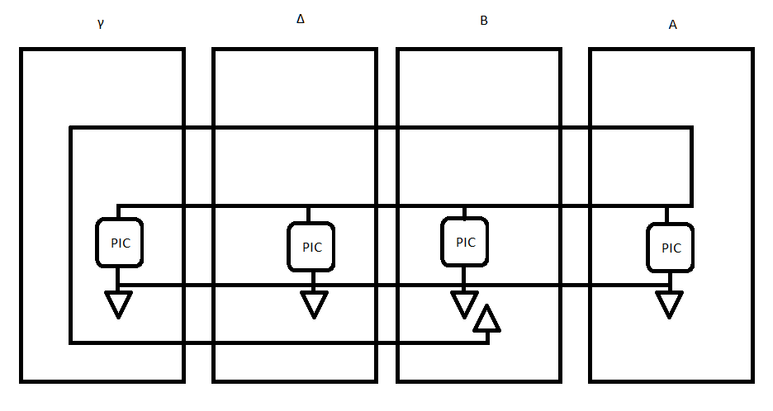

Figure -E-Shaped Circuit

## Security

The connection should be able to fit together each time the blades are without worrying if they are close enough. They should also be able to have at minimum 4 pins for the connection as well as being able to fit within the packaging of the blades.

# Possible Connectors

## Hotshoe Connectors

Hotshoe Connectors are surface mount contact connectors that can fit together through their physical casing. They can be soldered from behind to complete the connection when the male and female end connect.

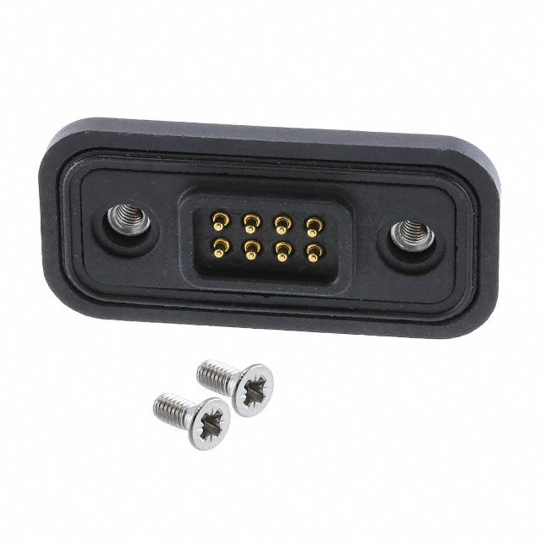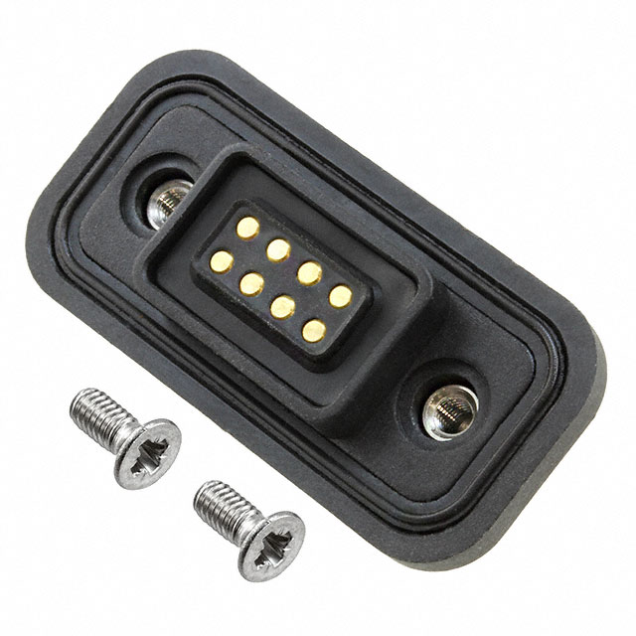

Figure 2- Male Connector Figure 3 -Female Connector

## Spring Contact Connector

Spring Contact Connectors are surface mount contact connectors that have metal pegs to press against each other when they connect. They can be soldered from one site to complete the connection when the male and female end connect.

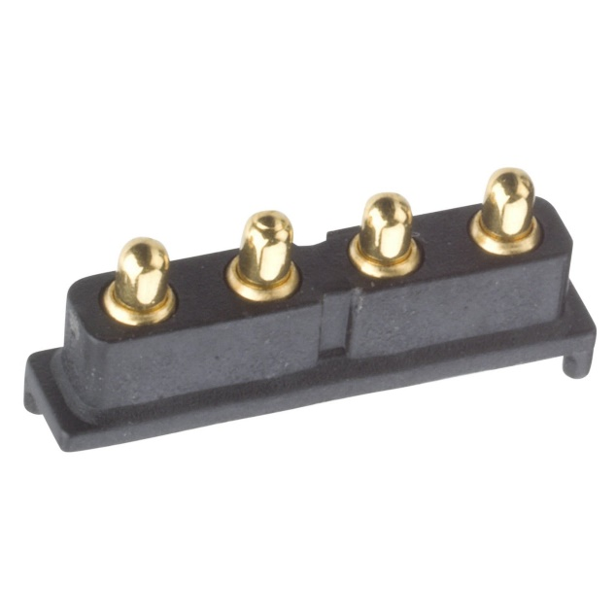

Figure 4- Spring Contact

## Magnetic Connectors

Magnetic Connectors are wire extensions with magnets on the end. They can be soldered to the end of a wire and can complete the circuit when they meet with another magnetic connector.

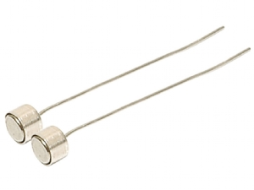

Figure 5- Magnetic Connectors

# Decision

The Hotshoe Connectors are the best fit for the project as they fit into each other and provide a secure connection between the contacts. While the Hotshoe contacts have more connections than needed, they provide a way for growth for the device if any other connections are needed.

# Software Goals

## Detect Completed circuit

There must be a system checking regularly or ready to activate when all four blades are connected. Once connected, it must be able to detect when the system is no longer connected.

## Adjust system settings

As each of the blades join together, they must change certain settings inside of them once they enter Omega Mode, such as Alpha no longer outputting IR.

After being in Omega Mode, the system must be able to detect when the system is no longer connected to the other blades and reset the programming to default settings.

## Flowchart

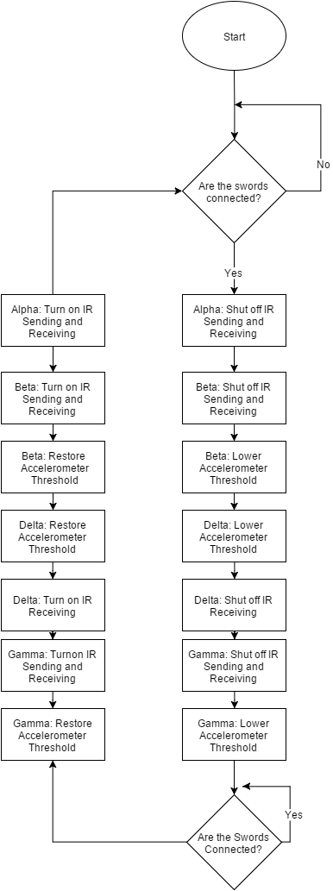

References

[1] Pololu.com, 'Pololu - MMA7341LC 3-Axis Accelerometer Â±3/9g with Voltage Regulator', 2015. [Online]. Available: https://www.pololu.com/product/1252. [Accessed: 05- Oct- 2015].

[2] Pololu.com, 'Pololu - MMA7361LC 3-Axis Accelerometer Â±1.5/6g with Voltage Regulator', 2015. [Online]. Available: https://www.pololu.com/product/1251. [Accessed: 05- Oct- 2015].

[3] Digikey.com, 'M90-7060845-ND| DigiKey', 2015. [Online]. Available: http://www.digikey.com/scripts/DkSearch/dksus.dll?Detail&itemSeq=181081919&uq=635796509370570113. [Accessed: 05- Oct- 2015].

[4] Digikey.com, 'M90-6050845-ND', 2015. [Online]. Available: http://www.digikey.com/scripts/DkSearch/dksus.dll?Detail&itemSeq=181086705&uq=635796509370570113. [Accessed: 05- Oct- 2015].

[5] Harwin, 'P20-0445R', 2015. [Online]. Available: https://www.harwin.com/products/P20-0445R/. [Accessed: 05- Oct- 2015].

[6] Sparkfun.com, 'SparkFun Triple Axis Accelerometer Breakout - ADXL337 - SEN-12786 - SparkFun Electronics', 2015. [Online]. Available: https://www.sparkfun.com/products/12786. [Accessed: 05- Oct- 2015].